NAMA:……………………………………………………... KELAS:………………………........



SMK BANDAR BINTANGOR

PEPERIKSAAN PERCUBAAN SPM 2025
PENDIDIKAN MORAL 1225/1
KERTAS 1
TINGKATAN 5
2 JAM 30 MINIT

JANGAN BUKA KERTAS SOALAN INI SEHINGGA DIBERITAHU
Untuk kegunaan pemeriksa
Bahagian | Soalan | Markah penuh | Markah diperoleh
A | 1 | 10
 | 2 | 10
 | 3 | 10
 | 4 | 10
 | 5 | 10
B | 6 | 10
 | 7 | 10
C | 8a | 4
 | 8b | 8
 | 8c | 8
 | 9a | 4
 | 9b | 8
 | 9c | 8
 |  | Jumlah

- Tuliskan nama dan kelas anda pada ruang
yang disediakan
- Kertas soalan ini mengandungi 3 bahagian:
Bahagian A, Bahagian B dan
Bahagian C
- Jawab semua soalan bahagian A, 1 soalan
daripada bahagian B dan jawab semua
soalan Bahagian C.
- Jawab semua soalan di dalam kertas soalan.
- Semua jawapan mesti berlandaskan
nilai-nilai moral.

Kertas soalan ini mengandungi 13 halaman bercetak termasuk kulit depan.

Disediakan oleh: Disemak oleh: Disahkan oleh:

___________________ ____________________________ ___________________
(Pn. Paat Hie Ching) (Pn. Siti Rafidah Bt Muhaladdin) (Nurhana Binti Hussen
Guru MP PM Ketua Panitia PM PK1 SMKBB

Bahagian A: 50%
Jawab semua soalan.

- Gambar berikut menunjukkan kejayaan pemain badminton Lee Zii Jia.
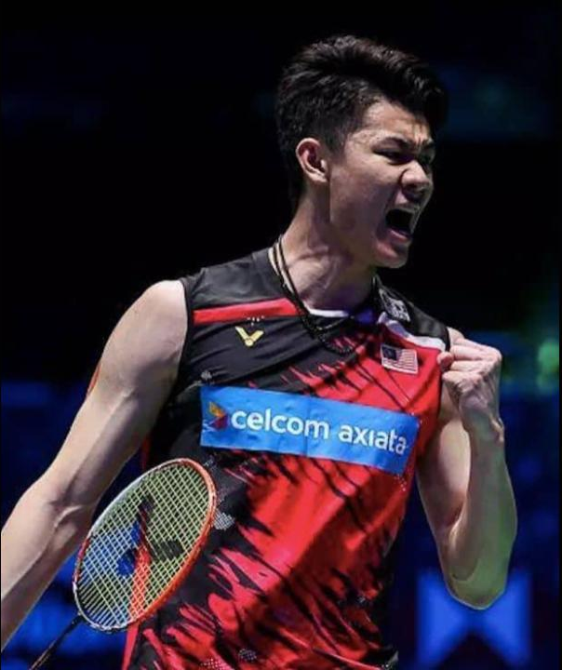
KUALA LUMPUR – Pemain nombor satu negara, Lee Zii Jia berjaya merangkul kemenangan sebagai Juara Kejohanan Badminton All England 2021. Beliau menewaskan pemain dari Denmark, Viktor Axelsen dengan tiga permainan 30-29, 20-22 dan 21-9. Kejayaan di Birmigham itu ternyata membanggakan rakyat Malaysia dan diraikan dengan penuh kegembiraan.
- Nyatakan dua nama atlet lain yang mengharumkan nama negara?
_____________________________________________________________________________________________________________________________________________________________________________________________________________________________________________________________________________________________________________________________________________________________________
(2 markah)
- Jelaskan dua faktor kejayaan atlet Malaysia.

___________________________________________________________________________________________________________________________________________________________________________________________________________________________________________________________________________________________________________________________________________________________________________________________________________________________________________________ (2 markah)
- Huraikan dua nilai yang diamalkan oleh atlet negara.

________________________________________________________________________________________________________________________________________________________________________________________________________________________________________________________________________________________________________________________________________________________________________________________________________________________________________________________________________________________________________________________________________________________________________________________________________________________________________________________________________________________________________________ (4 markah)
- Faiz dapat 10A+ dalam peperiksaan SPM, dia juga pemain badminton negara. Dia dapat tawaran dalam bidang perubatan dan sukan di universiti terkemuka luar negara. Dia pilih tawaran sukan kerana pengaruh Lee Zii Jia. Patutkah Faiz membuat pilihan tersebut? Beri alasan anda.

______________________________________________________________________________________________________________________________________________________________________________________________________________________________________________________________________________________________________________________________________________________________________________________________________________________________________________________________________________________________________________________________________________________________________________________________________________________________________________________________________________________________________________________________________________________________________________________________________
(2 markah)

2. Gambar berikut menunjukkan aktiviti keldai dadah.

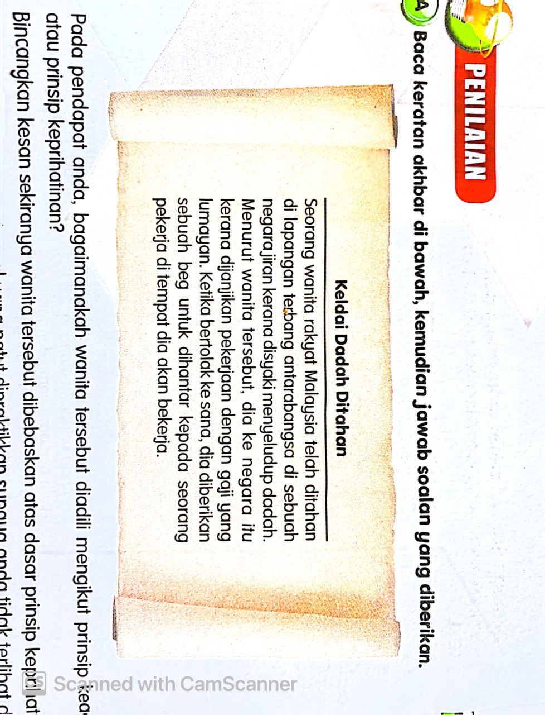

          - Pada pendapat anda, bagaimanakah wanita tersebut diadili mengikut prinsip keadilan atau prinsip keprihatinan?
______________________________________________________________________________________________________________________________________________________________________________________________________________________________________________________________________________________________________________________________________________________________________________________________________________________________________________
            - markah)
b) Bincangkan dua kesan sekiranya wanita tersebut dibebaskan atas dasar prinsip keprihatinan.

________________________________________________________________________________________________________________________________________________________________________________________________________________________________________________________________________________________________________________________________________________________
- markah)

- Jelaskan amalan nilai universal yang patut dipratikan supaya anda tidak terlibat dalam situasi ini.
______________________________________________________________________________________________________________________________________________________________________________________________________________________________________________________________________________________________________________________________________________________________________________________________________________________________________________
(4 markah)

- Bagaimanakah anda boleh mengelakkan diri daripada menjadi mangsa penipuan seperti kes ini?
______________________________________________________________________________________________________________________________________________________________________________________________________________________________________________________________________________________________________________________________________________________________________________________________________________________________________________
- markah)

3.Gambar dan maklumat berikut menggambarkan sikap wanita yang boros.

- Jelaskan perasaan anda apabila melihat gambar di atas.

________________________________________________________________________________________________________________________________________________________________________________________________________________________________________________________________________________________________________________________________________________________
- markah)

- Jelaskan dua kepentingan pengurusan kewangan secara beretika bagi mengelakkan berlakunya perkara seperti gambar B.
______________________________________________________________________________________________________________________________________________________________________________________________________________________________________________________________________________________________________________________________________________________________________________________________________________________________________________
(4 markah)

c) Ramalkan dua kesan jangka panjang sekiranya gambar A diamalkan dalam kehidupan harian.

______________________________________________________________________________________________________________________________________________________________________________________________________________________________________________________________________________________________________________________________________________________________________________________________________________________________________________
- markah)

d. Cerakinkan pengajaran yang boleh diperoleh daripada kedua-dua gambar.

________________________________________________________________________________________________________________________________________________________________________________________________________________________________________________________________________________________________________________________________________________________
- markah)

4. Gambar berikut berkaitan dengan bencana alam.

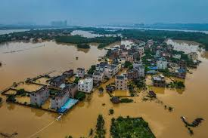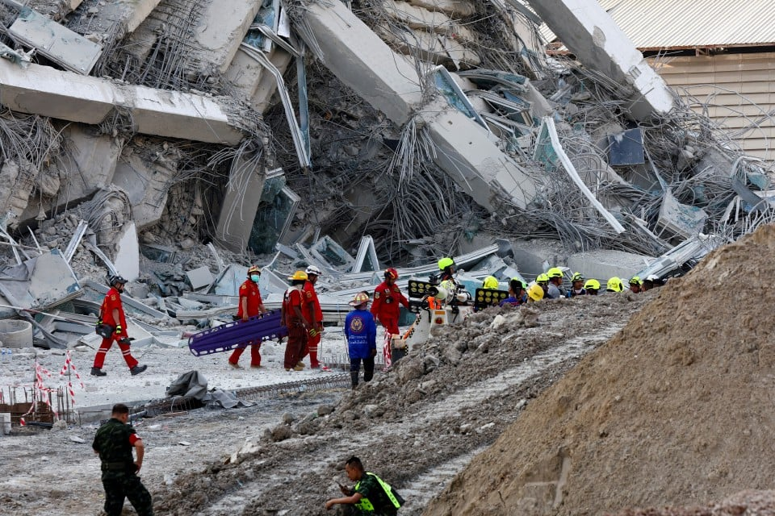
Banjir kilat Gempa bumi

- Senaraikan sikap berperikemanusiaan yang perlu diamalkan dalam situasi di atas.

________________________________________________________________________________________________________________________________________________________________________________________________________________________________________________________________________________________________________________________________________________________
- markah)
- Ramalkan kesan pengabaian sikap berperikemanusiaan terhadap mangsa.

______________________________________________________________________________________________________________________________________________________________________________________________________________________________________________________________________________________________________________________________________________________________________________________________________________________________________________
(2 markah)
- Terangkan kebaikan mengamalkan sikap berkeperimanusiaan dalam kehidupan harian.
______________________________________________________________________________________________________________________________________________________________________________________________________________________________________________________________________________________________________________________________________________________________________________________________________________________________________________
(4 markah)
- Jelaskan perasaan anda sekiranya berjaya mengamalkan sikap berperikemanusiaan demi kesejahteraan global.
______________________________________________________________________________________________________________________________________________________________________________________________________________________________________________________________________________________________________________________________________________________________________________________________________________________________________________
- markah)
5. Gambar berikut berkaitan dengan penipuan atas talian.

- Bincangkan tindakan yang patut dilakukan sekiranya anda menjadi mangsa dalam situasi atas.

______________________________________________________________________________________________________________________________________________________________________________________________________________________________________________________________________________________________________________________________________________________________________________________________________________________________________________
( 2 markah)
2. Ramalkan kesan lain yang berlaku sekiranya anda mengabaikan penggunaan teknologi maklumat dan komunikasi secara beretika.

____________________________________________________________________________________________________________________________________________________________________________________________________________________________________________________________________________________________________________________________________________________________________________________________________________________________________________________________________________________________________________________________________
( 4 markah)

3. Bagaimanakah amalan nilai universal mampu meningkatkan kesedaran anda dalam menangani isu di atas.

____________________________________________________________________________________________________________________________________________________________________________________________________________________________________________________________________________________________________________________________________________________________________________________________________________________________________________________________________________________________________________________________________
( 4 markah
Bahagian B: 10 %
Jawab 1 soalan Sahaja.

6. Gambar berikut berkaitan dengan muflis di kalangan masyarakat.

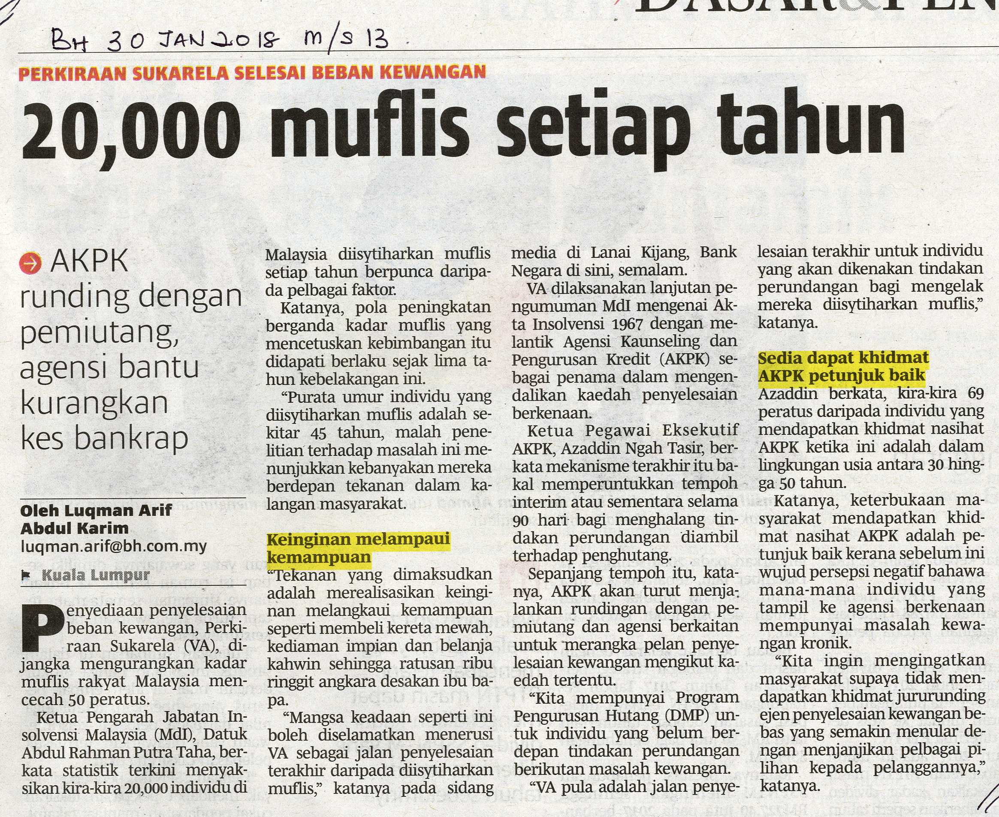

- Jelaskan kenapa isu muflis berlaku dalam kalangan masyarakat?

____________________________________________________________________________________________________________________________________________________________________________________________________________________________________________________________________________________________________________________________________________________________________________________________________________________________________________________________________________________________________________________________________
(2 markah)
- Bagaimanakah anda mengamalkan pengurusan perbelanjaan secara beretika dalam kehidupan seharian?

________________________________________________________________________________________________________________________________________________________________________________________________________________________________________________________________________________________________________________________________________________________________________________________________________________________________________________________________________________________________________________________________________________________________________________________________________________________________________________________________________________________________________________ ________________________________________________________________________________________________________________________________________________________________________________________________________________________________________________________________________________________________________________________________________________________________________________________________________________________________________________________________________________________________________________________________________________________________________________________________________________________________________________________________________________________________________________
______________________________________________________________________________________________________________________________________________________________________________________________________________________________________________________________________________________________________________________________________________________________________________________________________________________________________________________________________________________________________________________________________________________________________________________________________________________________________________________________________________________________________________________________________________________________________________________________________________________________________________________________________________________________________________
______________________________________________________________________________________________________________________________________________________________________________________________
(8 markah)

7. Setiap individu harus mengamalkan keperibadian mulia. Antaranya ialah berusaha bersungguh-
sungguh untuk melakukan kebaikan.

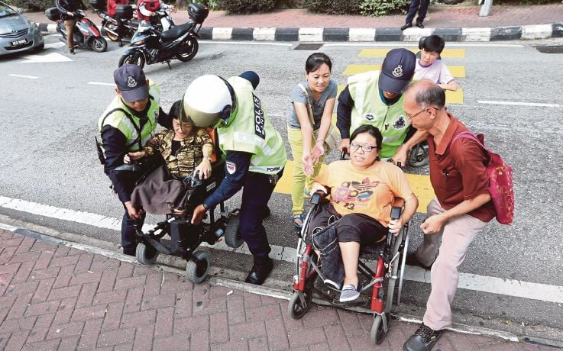

- Selain maklumat yang diberikan, nyatakan ciri individu yang berkeperibadian mulia.
__________________________________________________________________________________________________________________________________________________________________________________________________________________________________________________________________
(2 markah)
- Terangkan manfaat berkeperibadian mulia bagi seseorang individu.
______________________________________________________________________________________________________________________________________________________________________________________________________________________________________________________________________________________________________________________________________________________________________________________________________________________________________________________________________________________________________________________________________________________________________________________________________________________________________________________________________________________________________________________________________________________________________________________________________________________________________________________________________________________________________________________________________________________________________________________________________________________________________________________________________________________________________________________________________________________________________________________________________________________________________________________________________________________________________________________________________________________________________________________________________________________________________________________________________________________________________________________________________________________________________________________________________________________________________________________________________________________________________________________________________________________________________________________________________________________________________________________________________________
(8 markah)
Bahagian C:40%
Jawab semua semua.
8.Gambar berikut menunjukkan kes buli yang berlaku dalam kalangan pelajar di sekolah.

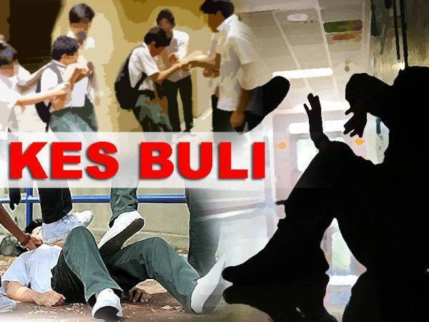

- Wajarkah kes buli berlaku di sekolah? Jelaskan.
___________________________________________________________________________________________________________________________________________________________________________________________________________________________________________________________________________________________________________________________________________________________________________________________________________________________________________________
(4 markah)

- Huraikan langkah yang boleh diambil oleh pihak sekolah untuk membendung kes buli di sekolah?
___________________________________________________________________________________________________________________________________________________________________________________________________________________________________________________________________________________________________________________________________________________________________________________________________________________________________________________________________________________________________________________________________________________________________________________________________________________________________________________________________________________________________________________________________________________________________________________________________________________________________________________________________________________________________________________________________________________________________________________________________________________________________________________________________________________________________________________________________________________________________________________________________________________________________________________________________________________________________________________________________________________________________________________________________________________________________________________________________________________________________________________________________________________________________________________________________________________________________________________________________________________________________________________________________________________________________________________________________________________________________________________________________________________________________ ____________________________________________________________________________________________________________________________________________________________________________________________________________________________________________________________________________________________________________________________________________________________
(8 markah)
- Jelaskan kesan membuli kepada mangsa buli di sekolah.
______________________________________________________________________________________________________________________________________________________________________________________________________________________________________________________________________________________________________________________________________________________________________________________________________________________________________________________________________________________________________________________________________________________________________________________________________________________________________________________________________________________________________________________________________________________________________________________________________________________________________________________________________________________________________________________________________________________________________________________________________________________________________________________________________________________________________________________________________________________________________________________________________________________________________________________________________________________________________________________________________________________________________________________________________________________________________________________________________________________________________________________________________________________________________________________________________________________________________________________________________________________________________________________________________________________________________________________________________________________________________________________________________________________________________________________________________________________________________________________________________________________________________________________________________________________________________________________________________________________________________________________________________________________________________________________________________________________________________________________________________________________
(8 markah)
9. Pernyataan di bawah menunjukkan kejayaan pelakon kelahiran Malaysia, Tan Sri Michelle
Yeoh.
Pelakon kelahiran Malaysia yang mencipta nama di Hollywood, Tan Sri Michelle Yeoh telah mengharumkan nama negara apabila Berjaya dinobatkan sebagai pelakon wanita terbaik, di Anugerah Academy atau Oscar di Los Angeles, Amerika Syarikat baru-baru ini. Kejayaan beliau membuktikan bahawa rakyat Malaysia mampu bersaing di peringkat global.

- Selain maklumat di atas, berikan empat contoh kejayaan Malaysia di persada dunia.
___________________________________________________________________________________________________________________________________________________________________________________________________________________________________________________________________________________________________________________________________________________________________________________________________________________________________________________
(4 markah)

- Berdasarkan maklumat di atas, huraikan kepentingan menjadi individu glokal. Jawapan anda
hendaklah berdasarkan nilai universal yang dipelajari.
___________________________________________________________________________________________________________________________________________________________________________________________________________________________________________________________________________________________________________________________________________________________________________________________________________________________________________________________________________________________________________________________________________________________________________________________________________________________________________________________________________________________________________________________________________________________________________________________________________________________________________________________________________________________________________________________________________________________________________________________________________________________________________________________________________________________________________________________________________________________________________________________________________________________________________________________________________________________________________________________________________________________________________________________________________________________________________________________________________________________________________________________________________________________________________________________________________________________________________________________________________________________________________________________________________________________________________________________________________________________________________________________________________________________________
- markah)
- Terangkan implikasi jika seseorang itu tidak bersikap glokal?
_____________________________________________________________________________________________________________________________________________________________________________________________________________________________________________________________________________________________________________________________________________________________________________________________________________________________________________________________________________________________________________________________________________________________________________________________________________________________________________________________________________________________________________________________________________________________________________________________________________________________________________________________________________________________________________________________________________________________________________________________________________________________________________________________________________________________________________________________________________________________________________________________________________________________________________________________________________________________________________________________________________________________________________________________________________________________________________________________________________________________________________________________________________________________________________________________________________________________________________________________________________________________________________________________________________________________________________________________________________________________________________________________________________________________________________________________________________________________________________________________________________________________________________________________________________________________________________________________________________________________________________________________________________________________________________________________________________________________________________________________________________________________________________________________________________________________________________ __________________________________________________________________________________________________________________________________________________________________________________________________________________________________________________________________________________________________________________________________________________________________________________________________________________________________________________________________________________________________________________________________________
- markah)

- Soalan tamat-

